This document will helps us in integrating Hive data warehouse with Microsoft Power BI, Microsoft Excel and custom .net Applcation.

1.Download ODBC Driver from microsoft website.

<https://www.microsoft.com/en-in/download/details.aspx?id=40886>

2. Open ODBC data sources in your machince.

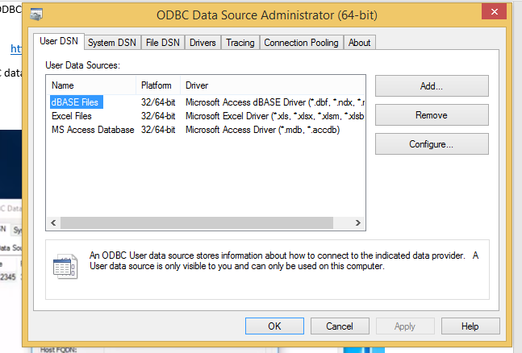

Add a new data souce name by clicking Add button.

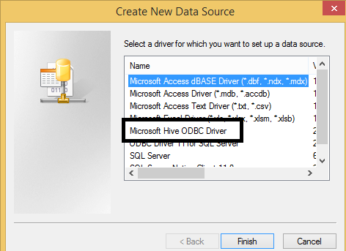

From the above image select Hive ODBC Driver.

Now you can see the following screen.

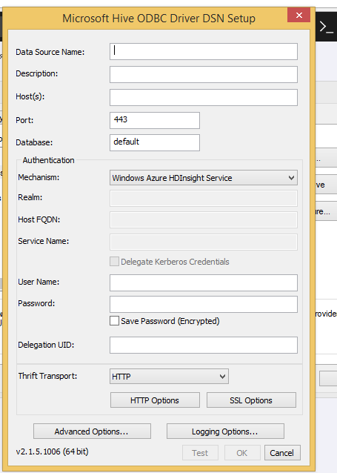

Please fll the above form with all details.

Now form looks like this

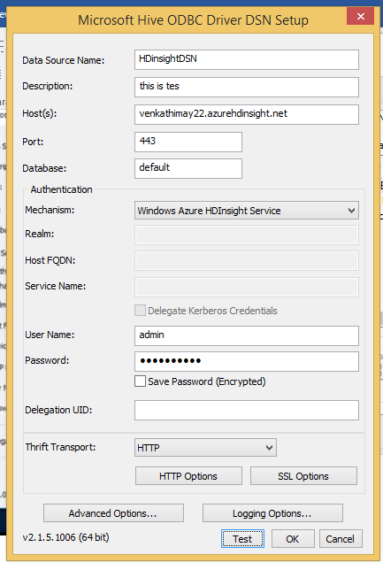

Go for Test Connection by clicking **Test** button.

You can see the following screen.

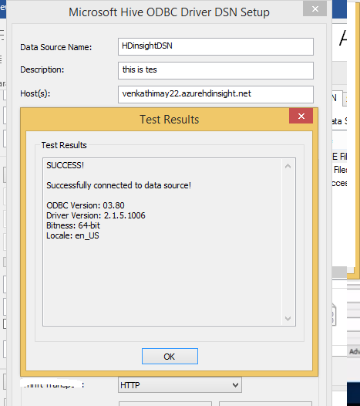

Then click OK button.

Now we try to integrate this with Power BI.

Click **GetData** and Select **Other** and Select **ODBC**.

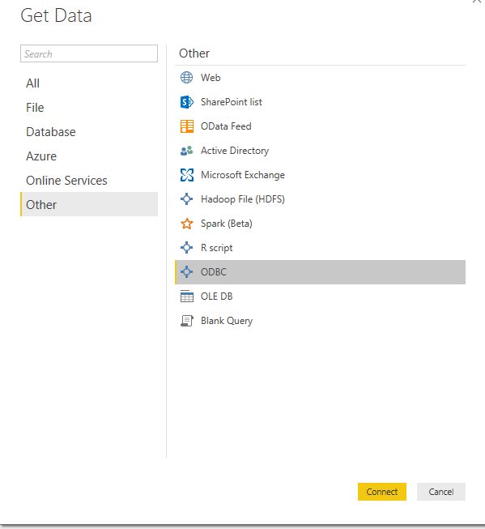

Click connect button, then it will display all the all the data sources as follows.

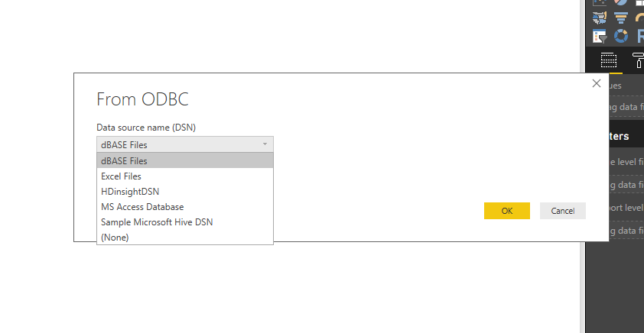

Here I am selecting my DSN, HDInsightDSN for connecting to Hive.

Following Screen will be displayed..

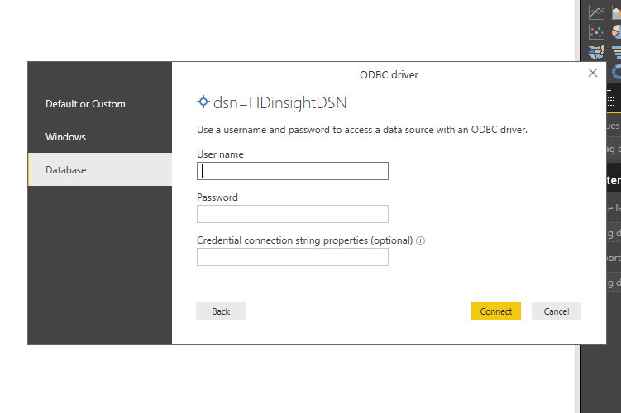

Enter your cluster credentials. After entering your credentials, the following screen will be displayed and select your table.

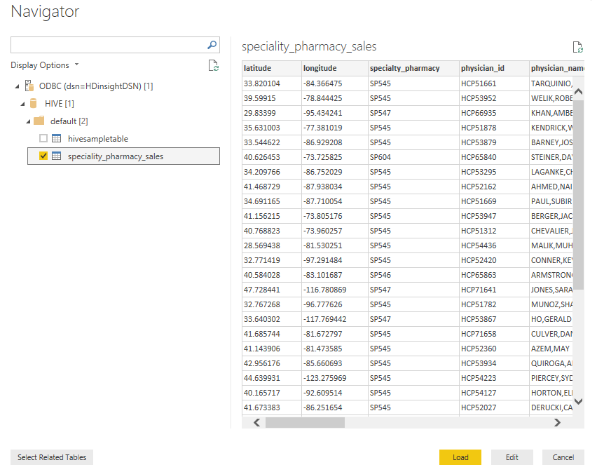

Here we can Edit for ETL or we can directly load the to Model, In this I am going to directly load into Model.

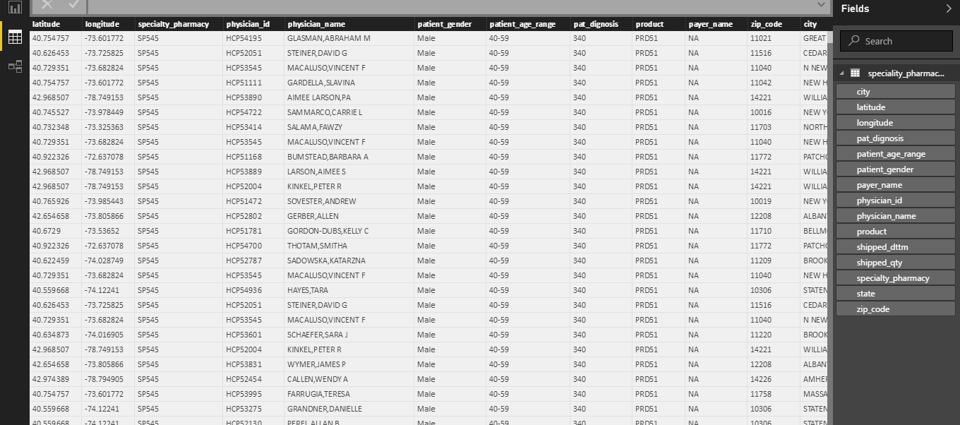

Now we have data in our data model, now we can go for visualizations and dashboards. Similarly we do have CloudEra Hive ODBC Driver.

Now we will look at integrating HIVE with Microsoft Excel.

1. Open Excel and follow these steps.

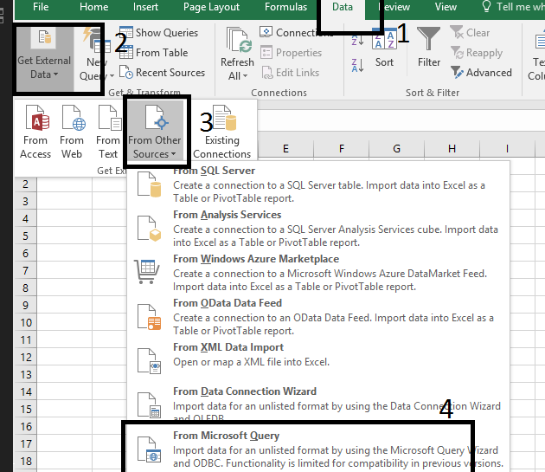

After selecting From Microsoft Query, it displays all the data sources as follows.

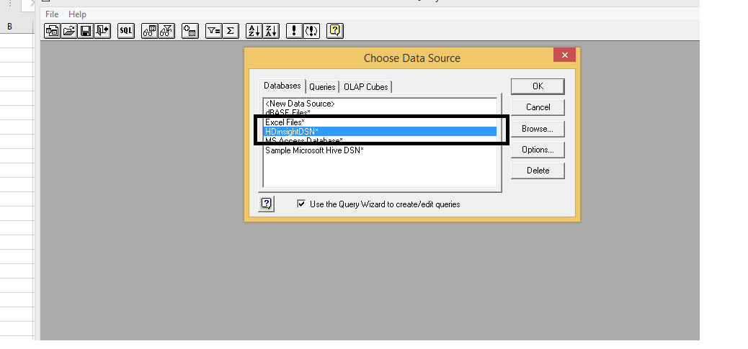

Select your HIVE DSN and click OK then the following screen will be displayed and please enter your pass word.

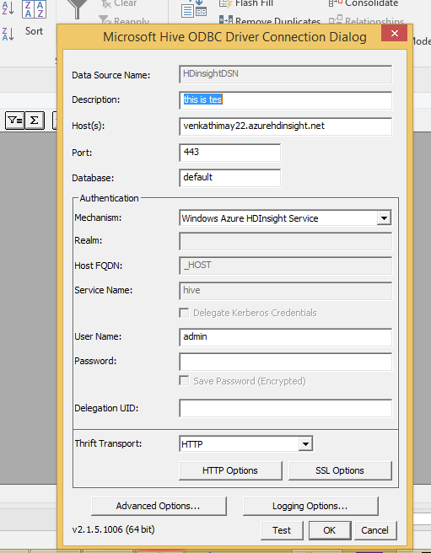

After connecting successfully, you will be displayed tables and select your table.

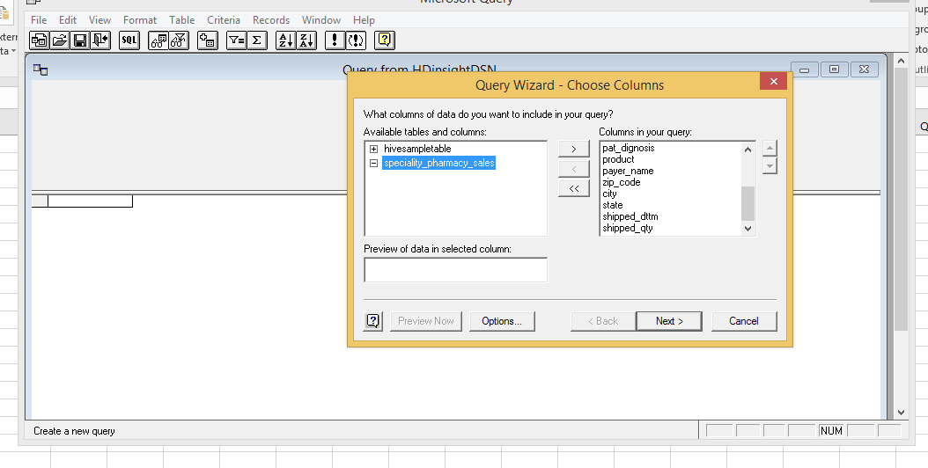

Select table and columns and click next button.

In the next dialog box you can for applying filters.

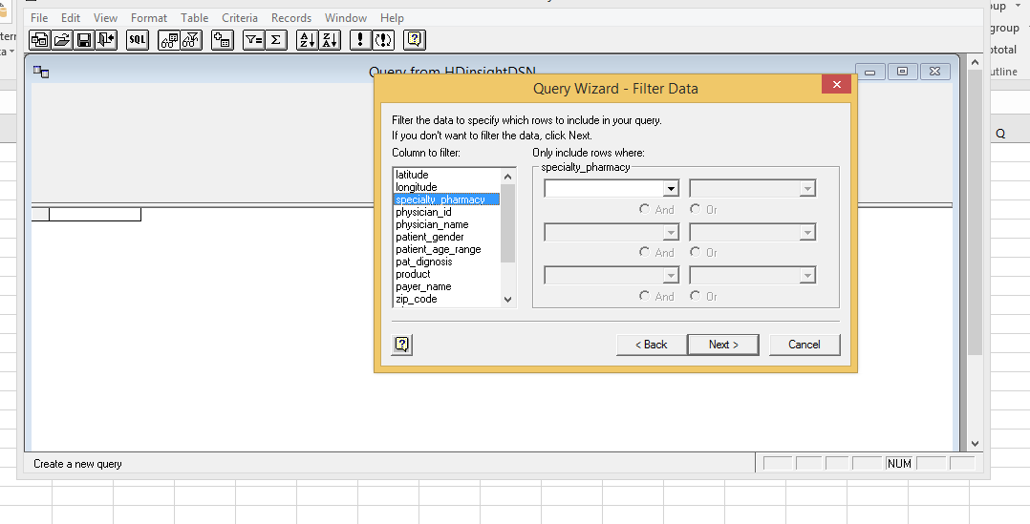

In next dialog box you can apply sort operations else just click next button. In the next dialog box you can select the appropriate option, I am selecting return data to excel.

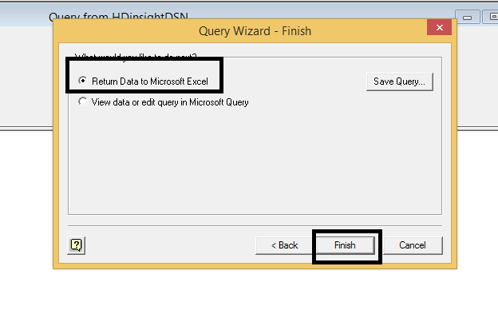

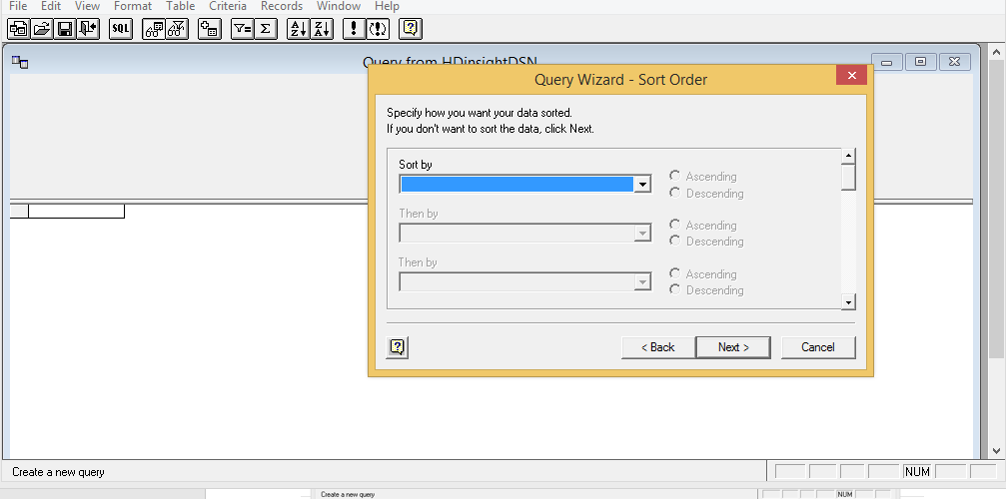

Now the will be loaded to Microsoft excel. Please the data loaded into Excel.

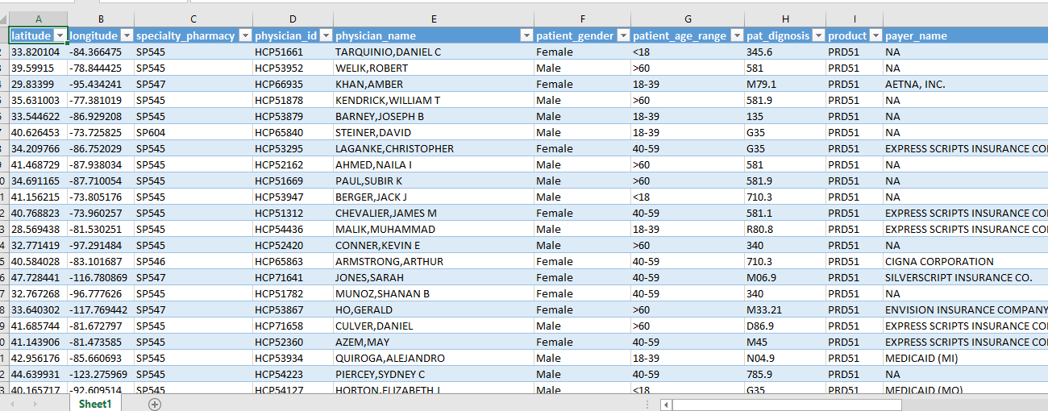

Next we will table to integrate Hive in custom dot net application.